Git and GitHub-02

Git and GitHub-02 Video:
- There are 5 branches Release, Develop, Feature, Hotfix and Master/main branch.
- How to add new branch git branch (branch).
- Now we are adding all 5 branches using command- git branch (branches)
- To verify all the branches present, use command- git branch --list.

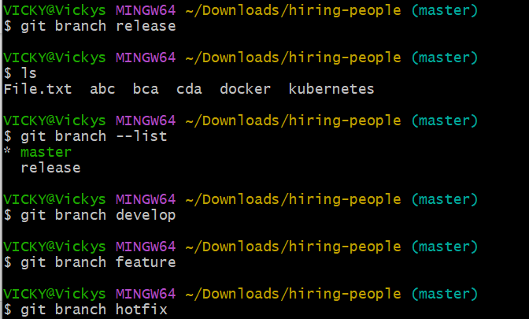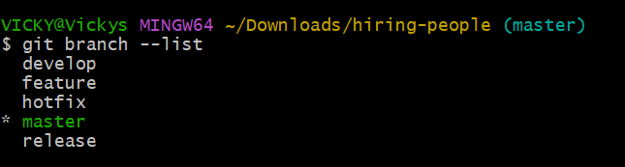

- To switch to other branches, use command- git checkout (branch), here we checked out to “Release branch”
- Now we are in Release branch.
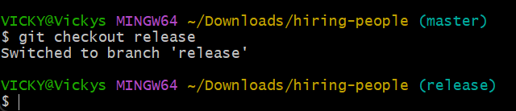

- How to merge only one file to another branch?
Merging only 1 file is not possible, but we can merge one commit to another branch.
Use command Git log to copy the commit-5 digits.
Use command Git checkout to switch to another branch.
Use command Git cherry-pick (commit) which we copied earlier and then enter.
- Now the commit is present in the new branch.
- The commit- hotfix was copied to master branch from hotfix branch using cherry-pick command following commit id picked.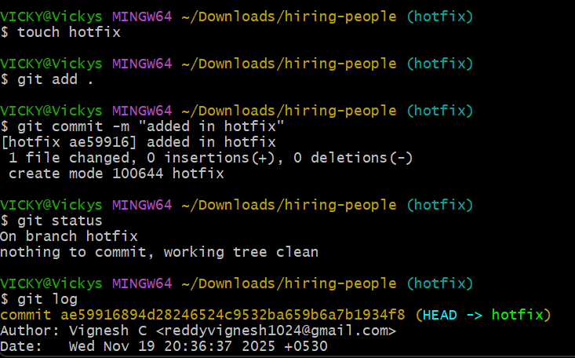 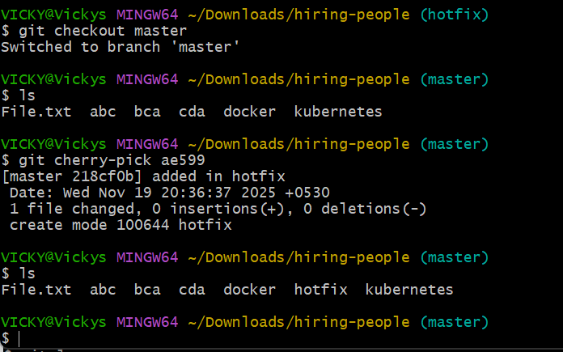
- Pull Request: Pull request is same as Git Pull, but PR is done in GitHub and Git Pull is done in Git (local machine).
- 1 pull request completed in GitHub as a assignee myself.

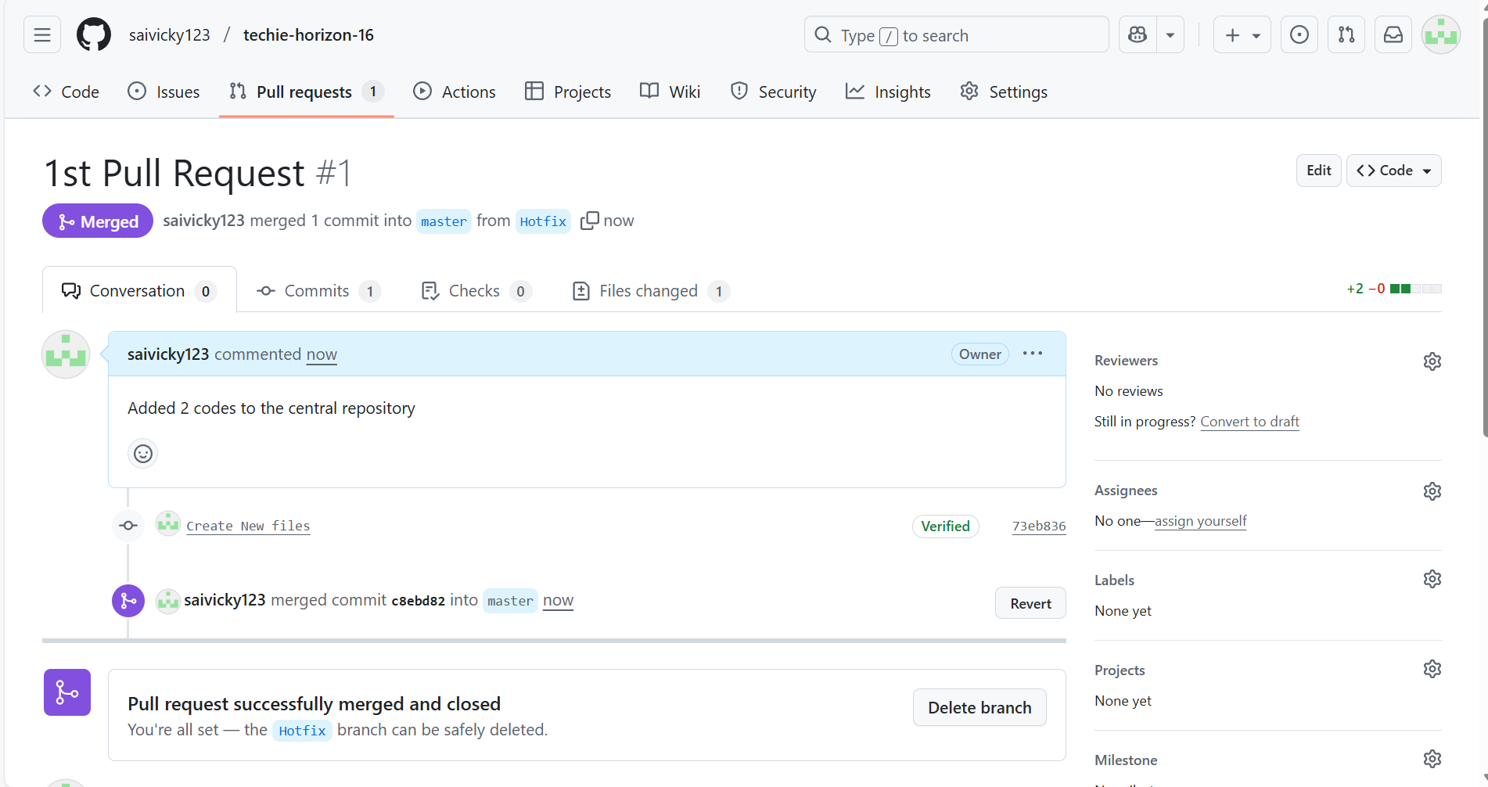

- How to stash a file from a branch without using “Commit”.
  - Create a file do git add . then command “git stash” Now the file is moved to stash area.
  - To regain the file when ready use command git stash list git stash pop and we can commit that file.
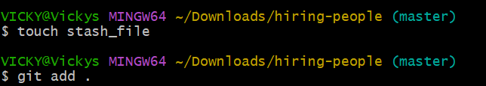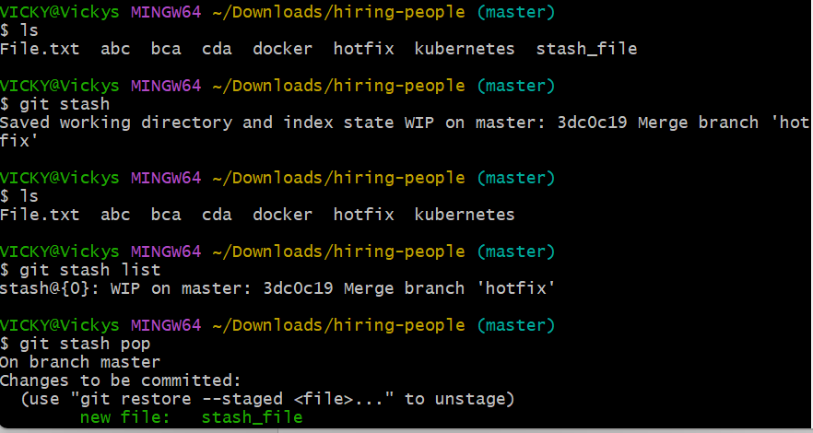

Merge Conflict
- To merge from one branch to another, we should not have any identical content in file.
- For example, I cannot have similar content in both the files in both the directory. File- Docker and content is Hello world in Master branch and Hello Cat in Release branch. So, Hello content is same in both the branches in same file.
- Then Merge conflict will happen when git merge branch command is executed.
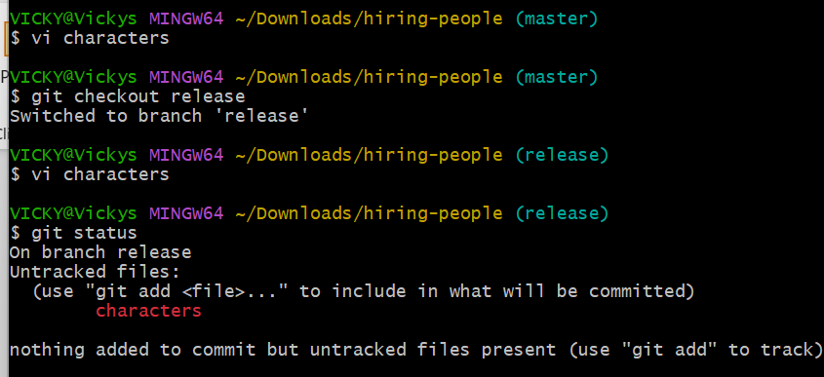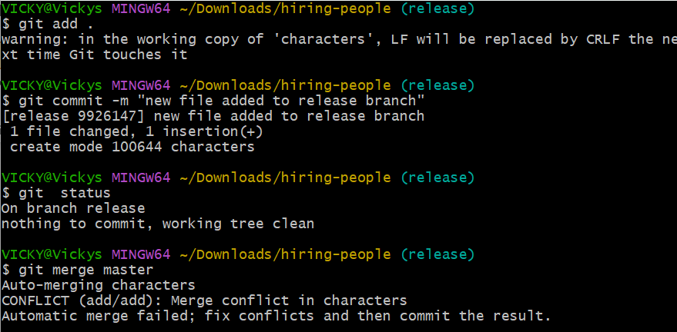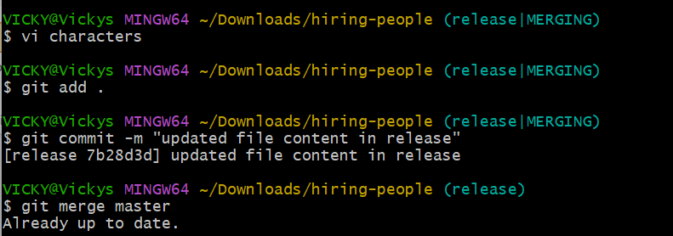

.gitignore
- What is .gitignore
  - This is a process, where we can hide our files in GitHub without any collaborators viewing them.
- Steps:
  - Touch (filename)
  - Vi (filename)
  - Vi .gitignore enter the filename in vi, so the file will be ignored in GitHub)
  - Git add .
  - Git commit -m “message”
  - Git push -u origin (branch)
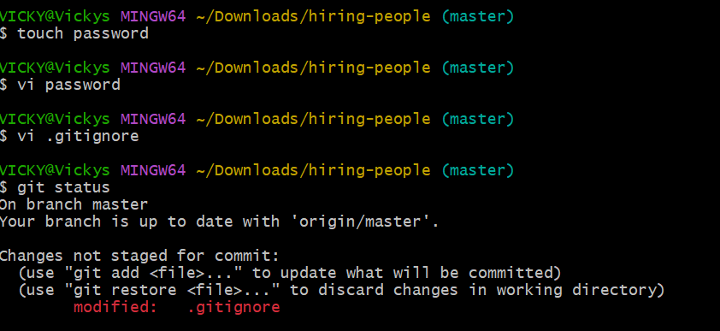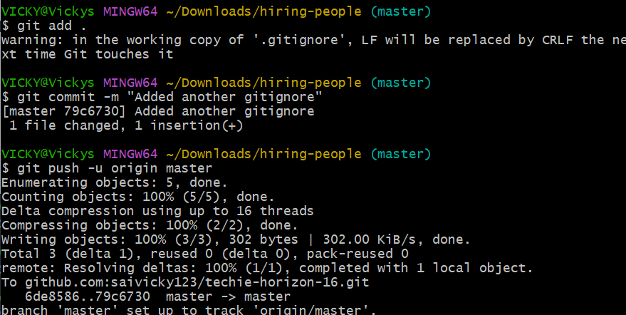

- Now the file is pushed to GitHub and can be viewed as “.gitignore” in GitHub
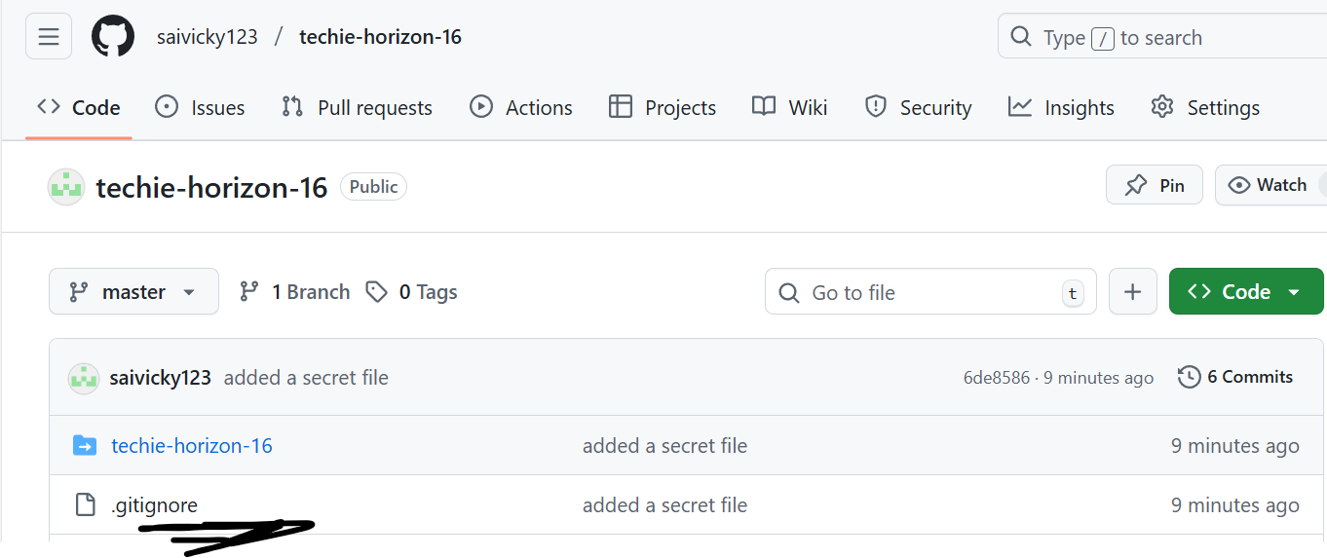
Readme.md

Readme.md is important when sharing the link to team members, where the instructions will help the team members to navigate and execute the project.
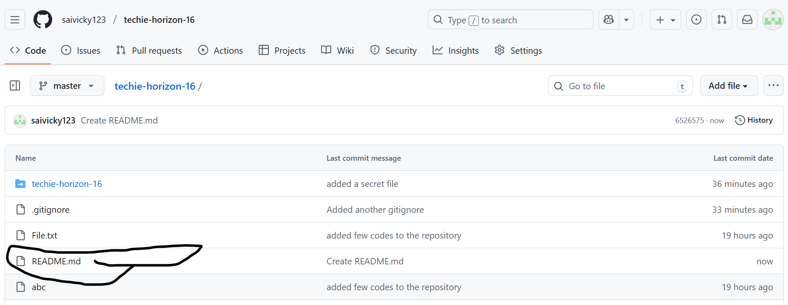
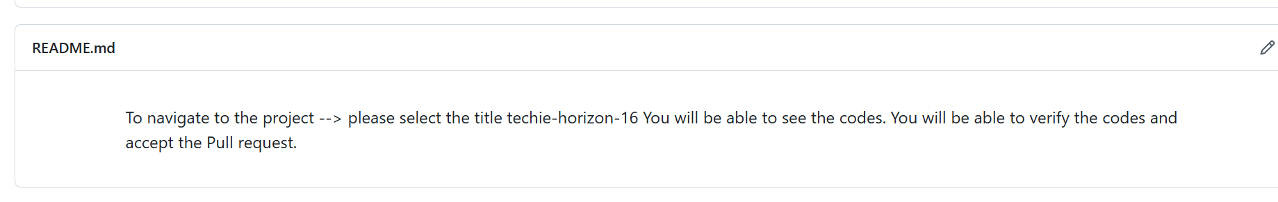

Git Fetch

- What is the diff between Git pull and Git Fetch?
Ans. Git Fetch will help us to download the configuration details whereas, Git pull will download the files from GitHub the latest codes.
Commands- git fetch origin (branch)
Git pull origin (branch)
- In the below, I created a file in GitHub as “New file”. While using the command- git fetch origin master, the config got fetched and by using command- git pull origin master, the file got downloaded in our local system.
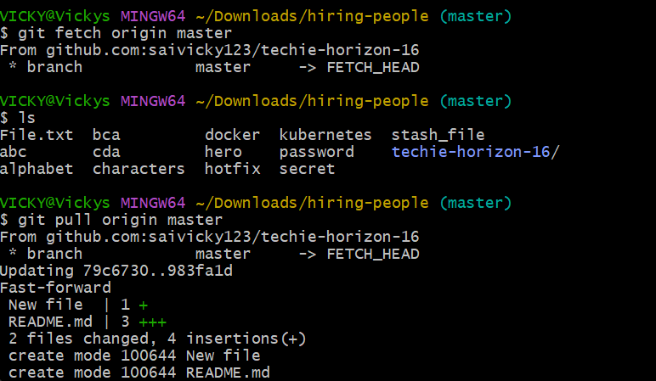
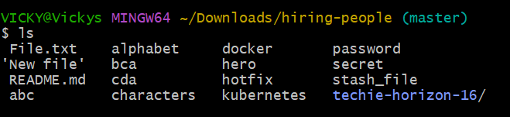

Git and GitHub-02 Task

- Install git.
- When we install Gitbash, Git will be installed automatically.
- We can verify by using command- git --version
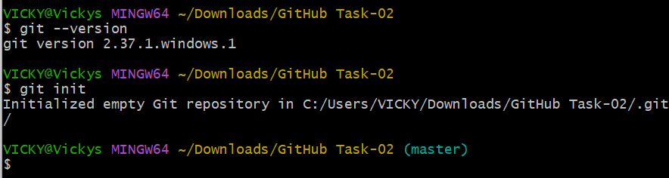

- Create a repo in GitHub with README.md and .ignore file.
- Created a file by touch password vi password to edit the password vi .gitignore to add password in the file git.add git commit -m “message” push the code to GitHub.
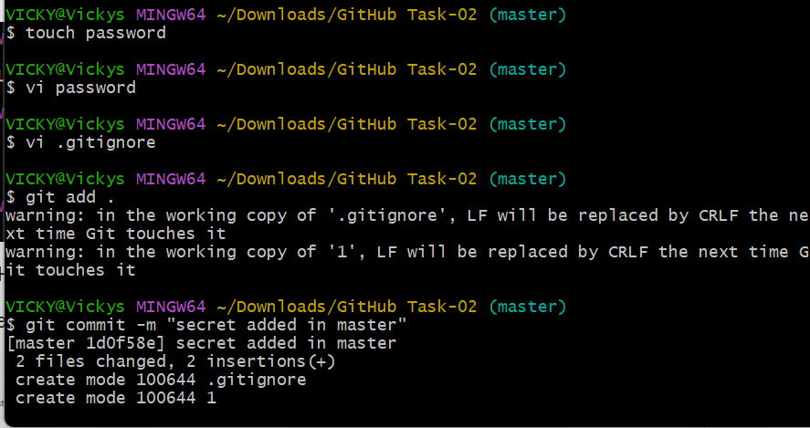

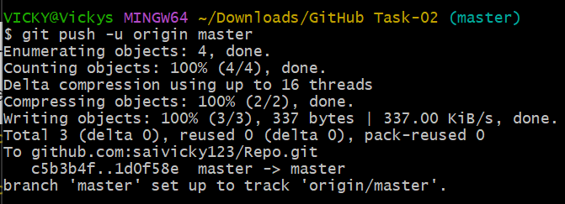
- .gitignore is pushed to GitHub and added a readme.md by adding a comment as a purpose.
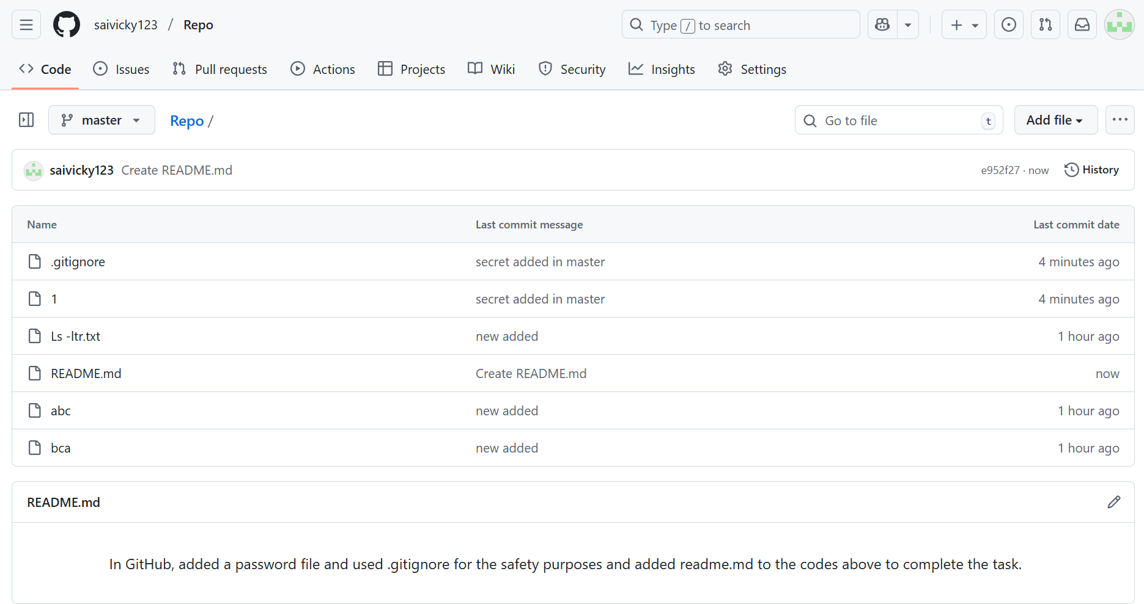
- Clone the created repo to local.
- Used command git clone and ssh-key from GitHub.
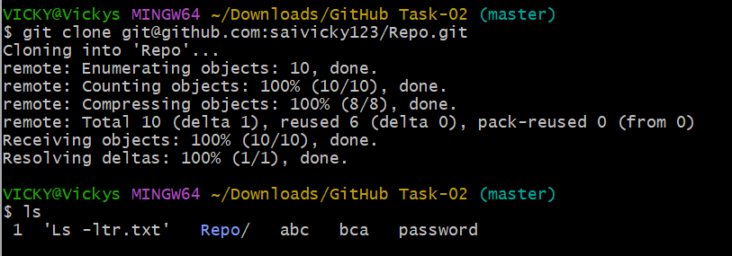
- Create two files in local repo.
- Commit two files and push to central Repository.
- Created two files in local repo using command- touch
- Pushed the two files using commands- git push -u origin master
- Verified in GitHub and the files are present.
- Success.
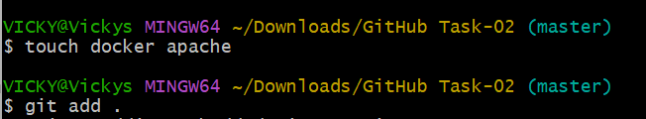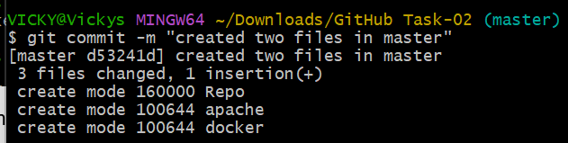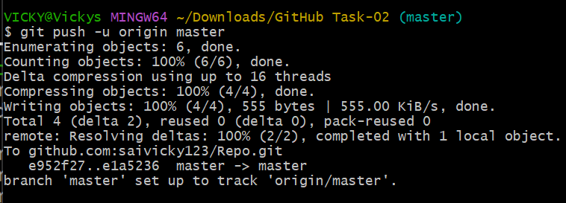
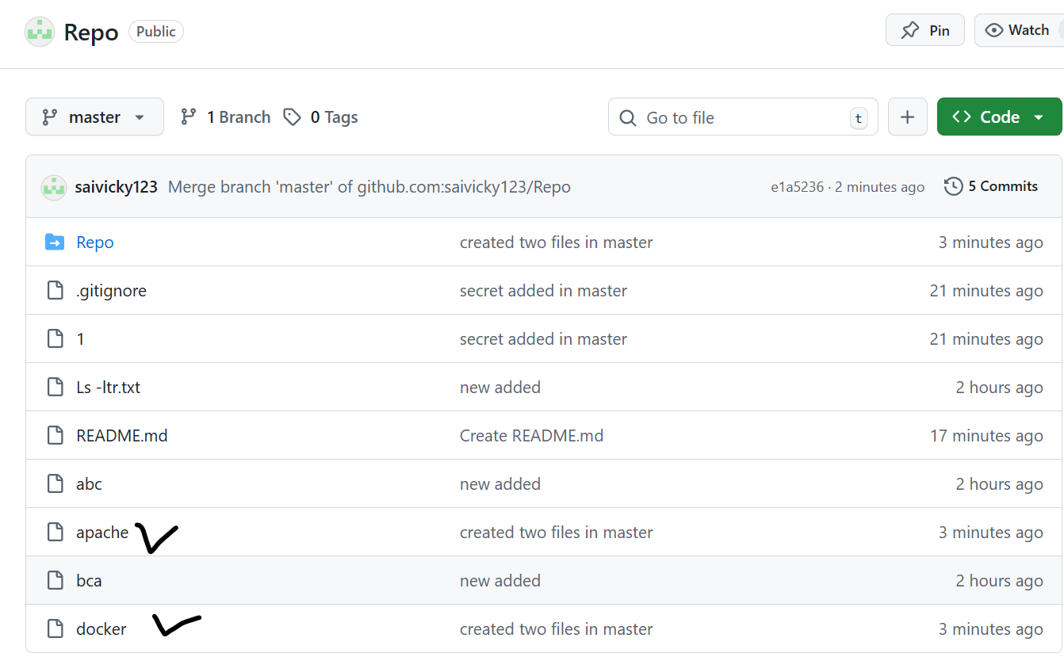

- Create a branch in local and create a sample file and push to central.
- First, we checked the branch list
- I created a branch called develop
- Switched to develop
- Created a file “develop”
- Added and commit the file
- Pushed to GitHub- Success.
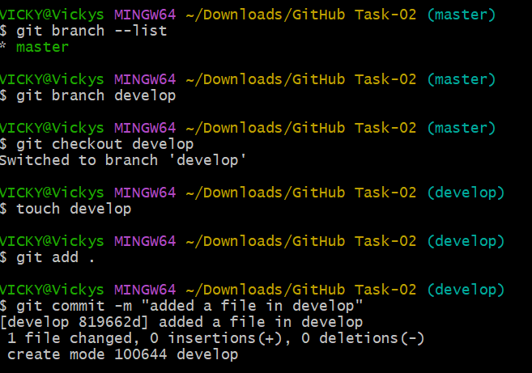
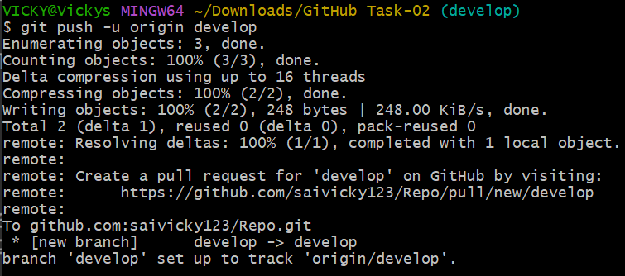
Central Repository confirming Develop file is available in Develop branch.
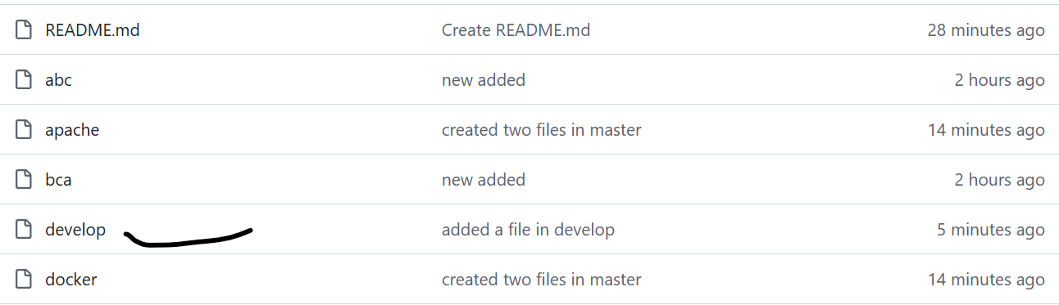
- Create a branch in GitHub and clone that to local.
- Created a branch in GitHub and cloned to local machine using command “git clone and ssh-key from GitHub”
- Success.
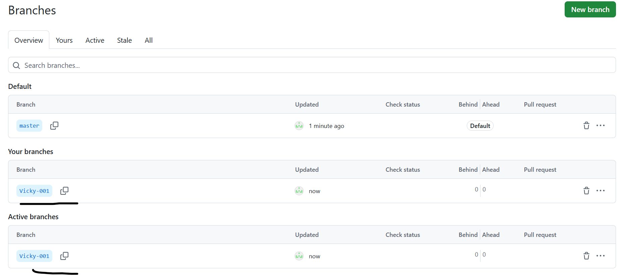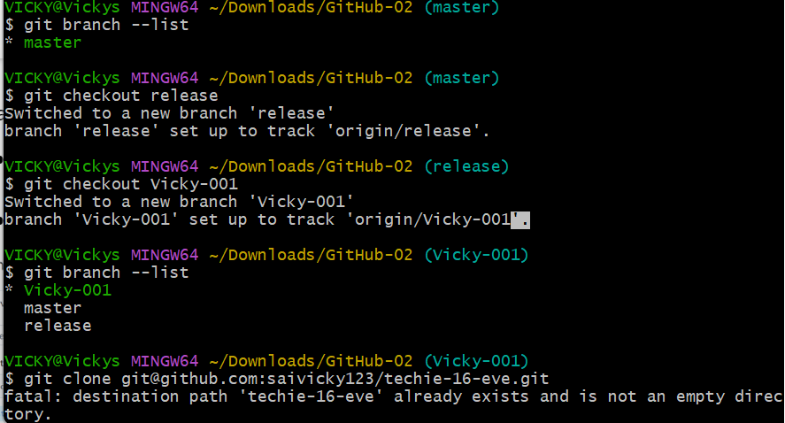

- Merge the created branch with master in git local.
- Verified git list and we have all the branches available from GitHub.
- To merge the new branch to master- git merge master
- Verified both the branches using ls command.
- Success.
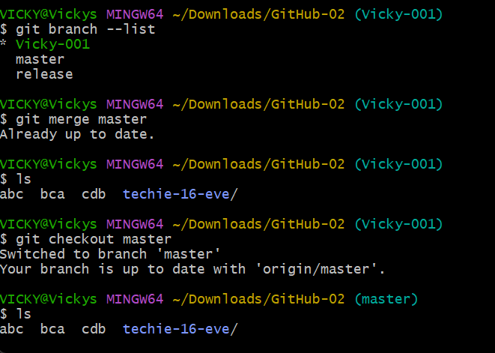
- Merge the created branch with master in GitHub by sending a pull request.
- Merged my branch – Vicky-001 to Master by sending a pull request.
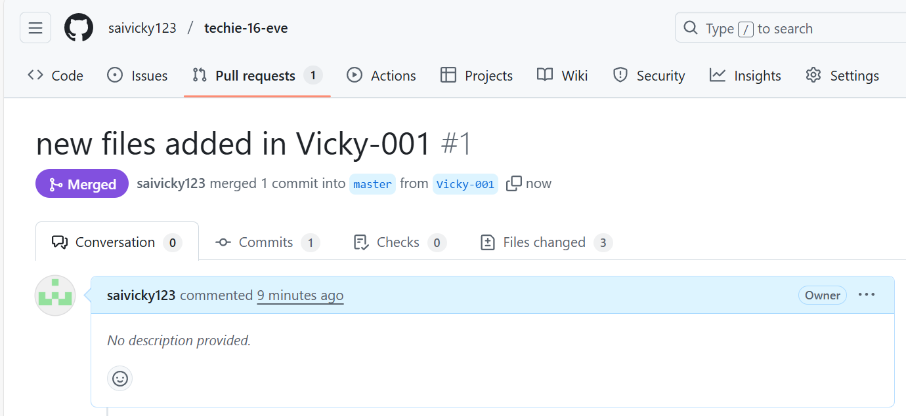
- Create a file in local and send that to branch in GitHub.
- Created a file in local and pushed the file to the same branch in Git Hub.
- Success.
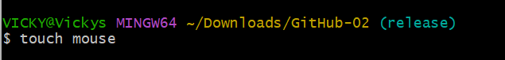
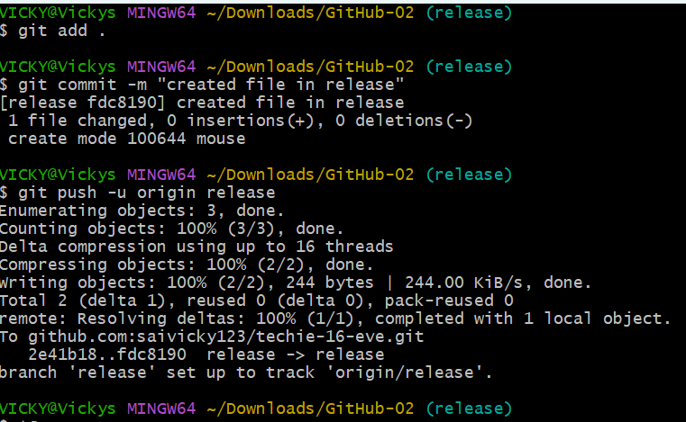
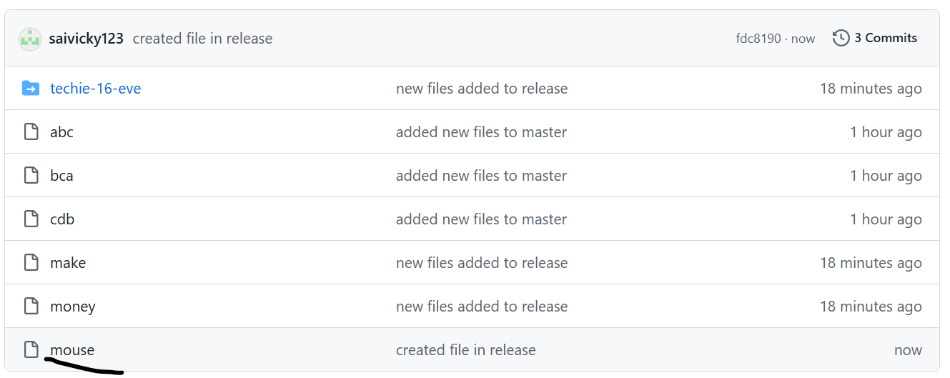

- Clone only a branch from GitHub to local.
- Cloned a branch from GitHub using command- git clone -b master (sshkey) from GitHub.
- Success.
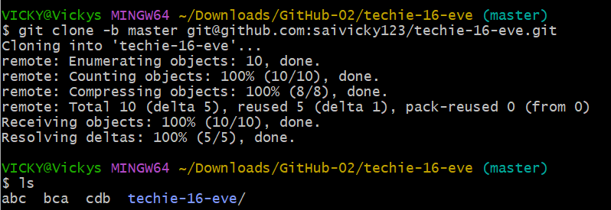

- Create a file with all passwords and make that untrackable with git.
- Created a file called Password
- Using vi password edited my password
- Using vi .gitignore, I updated the file name in it.
- Added the file
- Commit the file
- Pushed the file to GitHub and that file cannot be tracked by anyone except myself the owner.
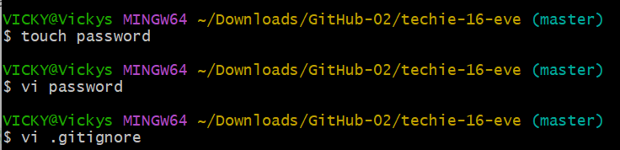
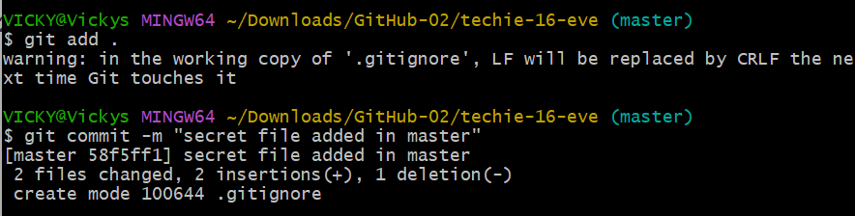
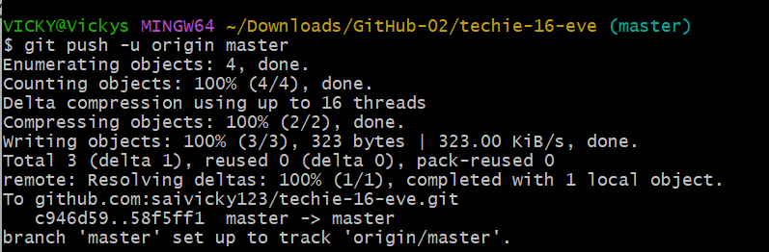
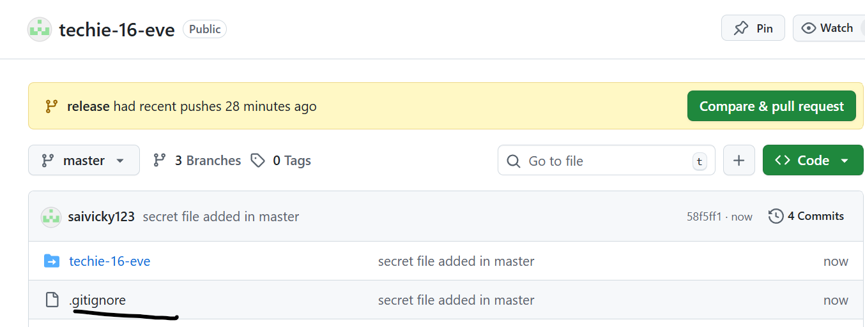
- Make a commit and make that commit reset without savings changes.
- Created a file and commit is done.
- Then we did reset using command- git reset –hard Head~1
- So, the 1st commit got reset without saving any changes.
- Success.
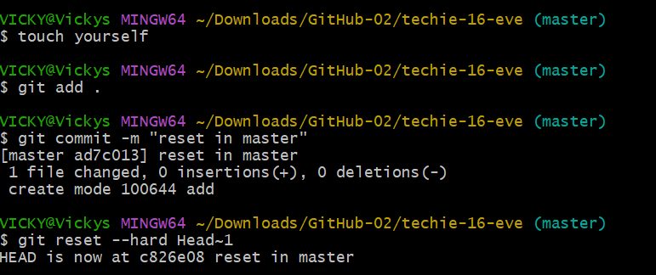
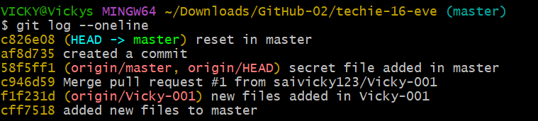

- Revert a commited commit to the older version.
- Using git log -4, we got previous 4 commit
- Using command- git reset 1st commit id done.
- Success.
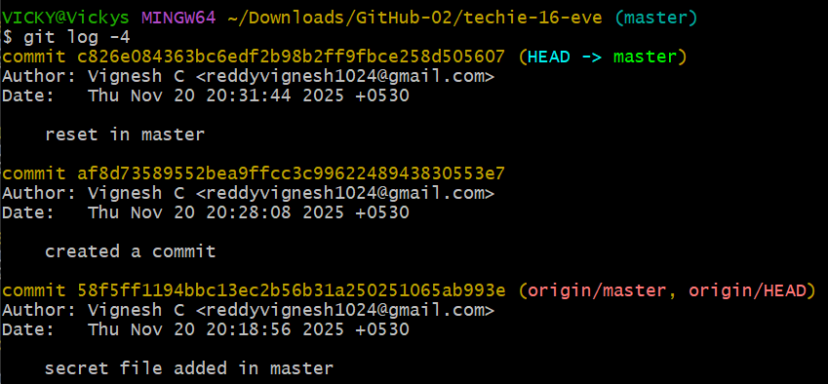
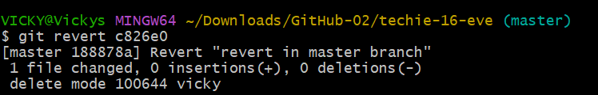

- Push a file to stash without savings the changes and work on another file.
- Created a file
- Used git command to add the file- git add .
- Command- git stash to stash the file
- In future, if we want to revert the stash file, then, command- git stash pop.
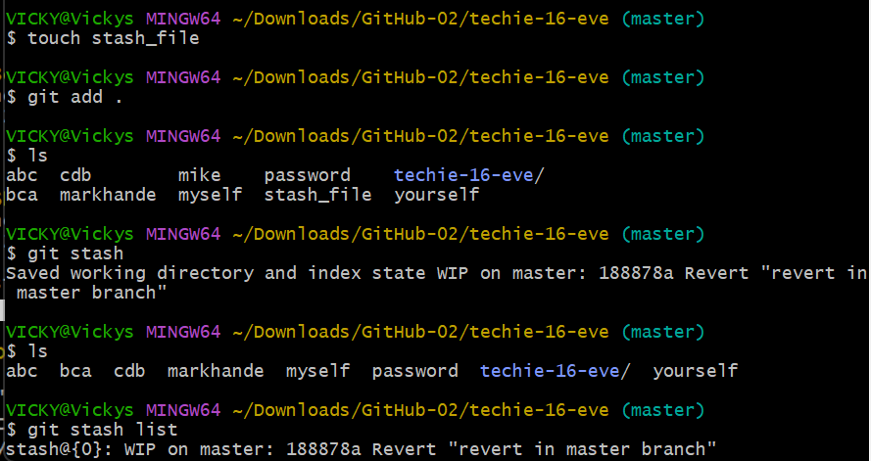
- Undo the stash file and start working on that again.
- For undo- command- Git stash pop
- Success.
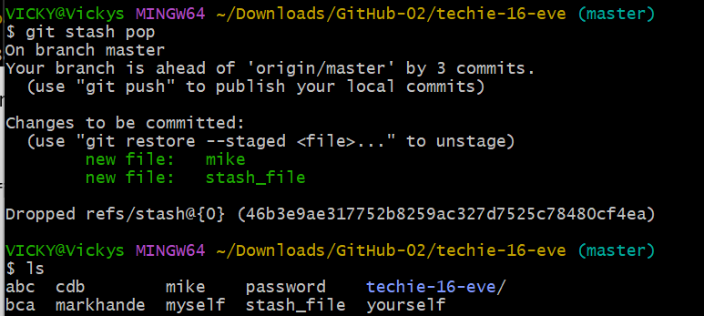

- Generate a ssh-keygen and configure into GitHub.
- Using ssh-keygen command, we created a public key.
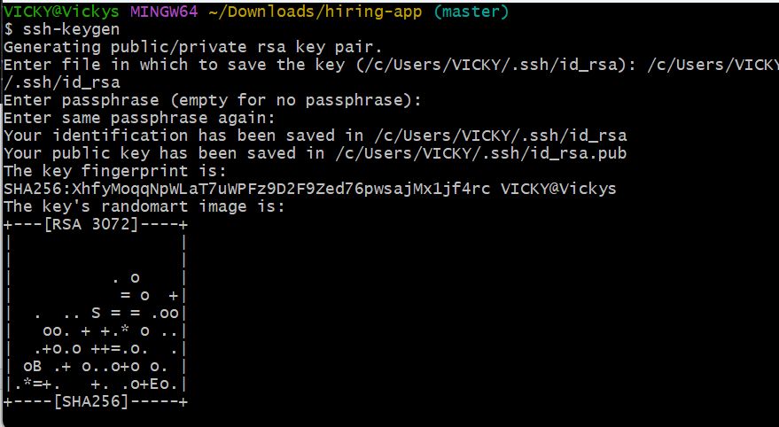
- Using CAT and public key .ssh from the ssh-keygen, we will create a ssh key, where the below key should be posted to the GitHub SSH keys by creating a new one.
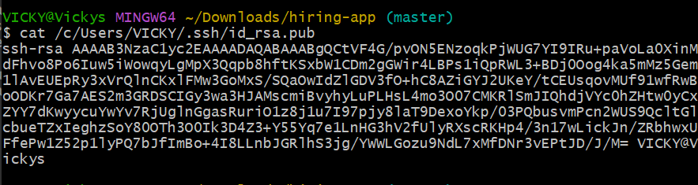

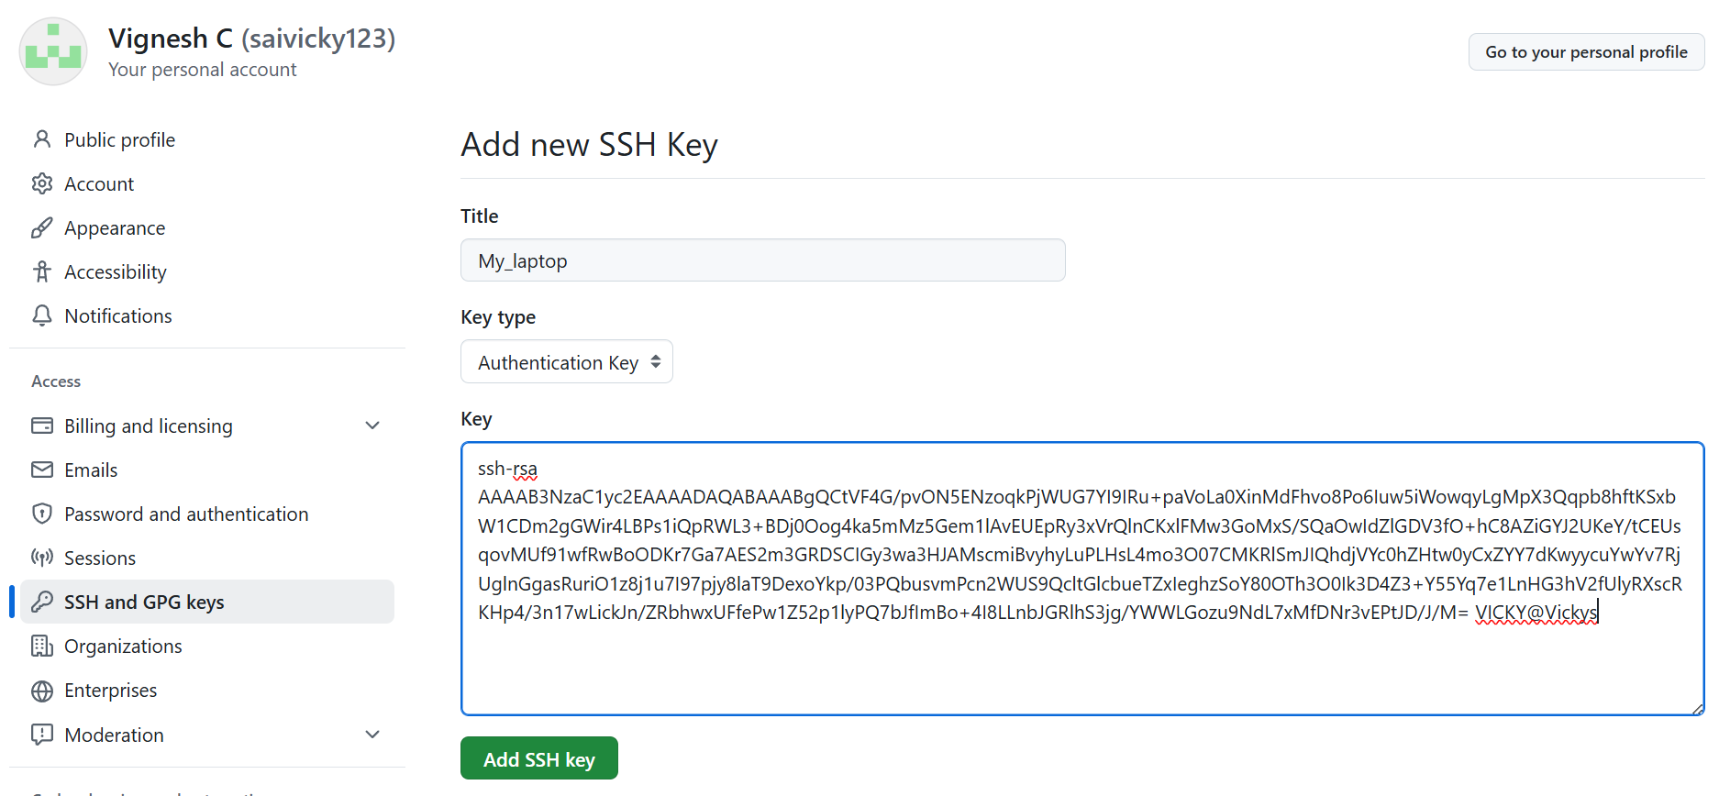
- Now a new SSH key has been created.
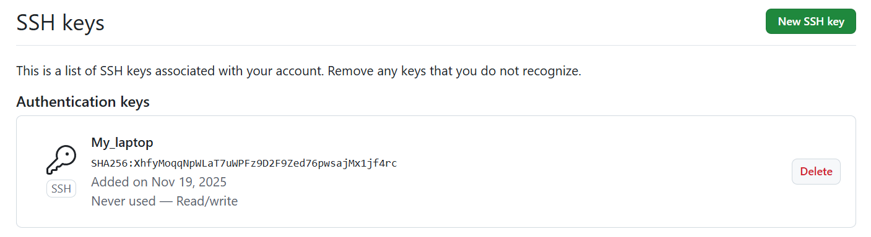

- Basic understanding of .git file.
When you run git init inside a project, Git creates a hidden folder called .git in your project directory.
“This. git folder is the heart of your Git repository”
What does the .git folder contain?
Here are the important parts (easy explanation):
1. HEAD
- Points to the branch you are currently on.
- Example: refs/heads/main
2. Config
- Contains Git configuration for this repository.
- Example: username, email, remote URL
3. refs/
Stores references (pointers) to commits:
- heads/ branches
- tags/ tags
4. objects/
- Most important folder
- Stores all Git data (commits, blobs/files, trees: the complete project history).
5. index
- The staging area file.
- Stores what is ready to be committed.
6. logs/
- History of operations like checkout, commit.
Why is the .git folder so important?
Because it stores the entire history of your project.
- If you delete the .git folder
:Your project becomes a NORMAL folder
- All history is lost
- Git commands will stop working.

- Check all the logs of git.
- Using command- git log, we can check all logs in git.
- If we want to check few logs, then git log (-n)
- Success.
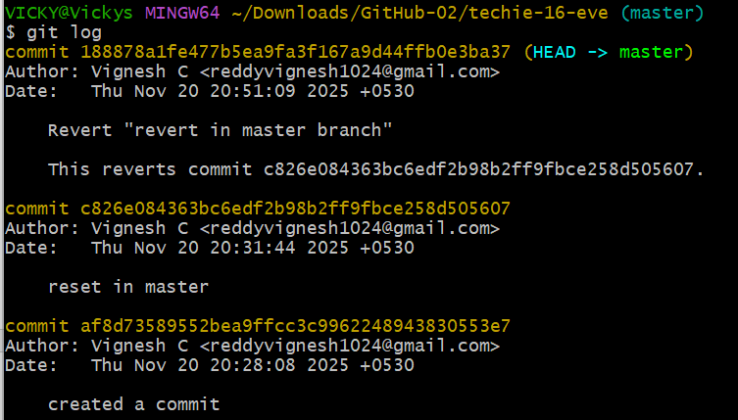
- Rename the commit message.
- Using command- git commit –amend, we can rename the commit message
- Success
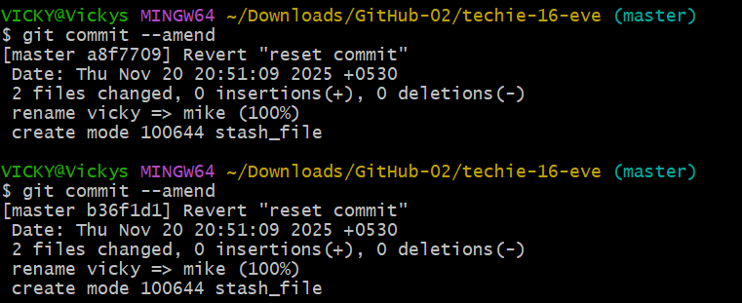

- Merge multiple commits into single commit.
- Merging multiple commits into single commit in Git-
- use command – git rebase -i Head~1
